FIT3179 Homework Assessment Week 10

Name: Ethan Ho Wye Kit

Monash Student ID: 32930267

Lab: 2

Tutor Name: Dr Grace Chai-Wen Ting

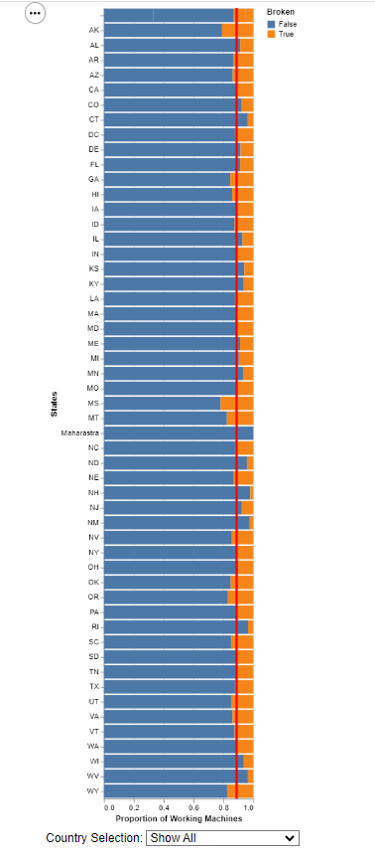

Figure 1: Task 1 Screen Capture

* Task 2 URL: <https://ehoo0018.github.io/HomeworkW10/>
* Domain of data visualisation 2 is **Restaurants**
* [Dataset](https://www.kaggle.com/datasets/thedevastator/mcdonalds-ice-cream-machines-broken-timeseries)
  + Quantitative Data
    - Latitude
    - Longitude
  + Nominal Data
    - State
    - City
    - Country
    - Is Broken
    - Is Active
* Stack bar chart to show **part to whole relationship** for all active ice cream machines that are still working.